**Chapter 3**

**RESEARCH METHODOLOGY**

**Environment**

The research study was conducted by the proponents in the province of Misamis Occidental, some parts of Zamboanga Del Sur, and Zamboanga Del Norte. Misamis Occidental is situated in the Northern Mindanao region of the Philippines which comprises 14 municipalities where lies in each either a terminal or a bus stop while Zamboanga is located in the Zamboanga Peninsula Region and has 26 municipalities but will be limited to only Dipolog, Dapitan, Tambulig and Molave.

**Research Respondents**

The respondents of the research study consisted of the van service owner, Mr. Reno Olmedo. A set of 20 drivers present during the day of the interview were chosen randomly with the use of the purposive sampling method since they will make use of the application. In addition, 30 more passengers who used Maria Evenia Van as their mode of transportation were also selected randomly to serve as respondents and their response will be used for the system. Overall, the total number of respondents is 51.

**Research Instrument**

The proponents used several research instruments to accumulate the required data to further comprehend and formulate more applicable ideas which are significant to the proposed research and guide them on how the application should be in accordance to the research objectives. The proponents made use of interview guide questions (See Appendix A) to gather important details from the van service owner and drivers while a survey form (See Appendix B) was created to gather opinions from the passengers.

**Data Gathering Procedure**

The proponents needed to procure an agreement towards the Maria Evenia Services to conduct the research with them as the client. Hence, the proponents secured a transmittal letter together with a Memorandum of Agreement to be signed by both parties.

The proponents then began to inquire of Mr. Reno Olmedo through his social media account of what he reckons about the proposed system and if he is willing to be part of it of previous to the proponents conducting an interview with the owner himself. He agreed with the proponents to meet in a coffee shop to further discuss the details about the proposed system.

During the interview, both the proponents and Mr. Olmedo communicated in an oral manner using the mixture of the languages English and Vernacular. The interview was recorded with the use of a smartphone which served as the recording device to gather the information accurately. A set of questions were given to Mr. Olmedo prior to the interview so he can prepare the necessary information needed. The drivers and passengers were personally approached by the researchers in a friendly and vocal manner with the use of the local language so both parties can understand each other completely.

**Treatment of Data**

The data and facts that had been gathered from the interviews conducted by the proponents from the respondents of the research study were filtered, organized and analyzed. By the use of interview method, the proponents can find useful information that is going to be applicable to the research study. It serves as the proponents’ guide in the developmental process of building the system.

For the presentation of the tabulated results, the following treatment was used for the data gathered. For questions that are answerable by yes or no, percentage and frequency were computed as shown below:

1. Frequency Count – the answer per questions in the questionnaire were quantify, counted and it is considered as frequency.
2. 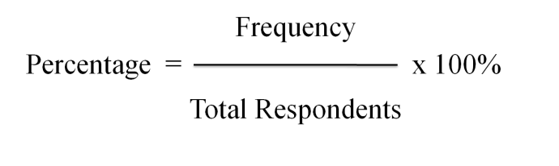Percentage

After getting the percentage, the results will be analyzed and documented to prove the willingness of people to have the system and it will be the basis on formulation to recommend this kind of project.